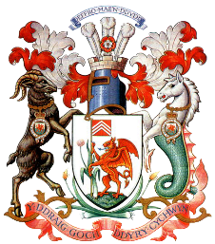
Cardiff Athletic Bowling Club
Centenary Dinner
Date: Fri 04 Aug 23
Time: 1900
Venue: Cardiff Athletic Club ‘Sir Gareth Edwards Lounge’
Dress: Suits
As this is our centenary year the Club will be holding a ‘Centenary Dinner’ at the above venue and as a member of the bowling club, you and a guest are invited. The dinner will consist of a 3-course meal. Also, there is entertainment with a 3-piece band and disco. The cost of the evening will be £35 each. At present there is only availability for one extra guest, however if you would like to bring additional guests, once, all the proformas are in a decision will be made on a first come basis. As soon as the menu has been finalised a Performa will be sent out for you to select your choice of starter and main course. But in the meantime, if you could return this letter and indicate whether would be attending or not.
Attending Yes/ No
Name:
Name of Guest: Mrs/Miss/Mr
Additional Guests:
Name:
Name:
If you require any dietary requirements, please can you indicate below and include their name:
Name:
Dietary Requirement:
Please could you return this form to Alan Meyer, or a Member of the Committee alternatively you could once completed email to:
cabc1924@gmail.com

